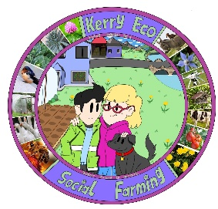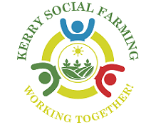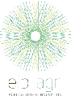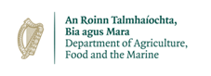
Author: Luke Myers
Kerry Eco-Social Farming – an EIP integrated within a Voluntary Model of Social Farming, addressing biodiversity, inclusion and accessibility on farms in Kerry.
Inclusive, community-based meitheals for invasive species
Overview – The Kerry Eco-Social Farming European Innovation Partnership Project (KESF EIP) is a nature-based project which was funded by the Department of Agriculture, Food and the Marine through the European Innovation Partnership fund. The project was integrated into a voluntary model of social farming, Kerry Social Farming, a community-based project which links up people with additional needs, acquired brain injuries and people utilising specific mental health services, with local volunteer farmers across the county in order to provide inclusion and accessibility on farms. The KESF EIP was a single year Call-5 EIP which focused on enhancing the social farming experience for host farmers and participants through the provision of funding, training and guidance on biodiversity and nature-based action.
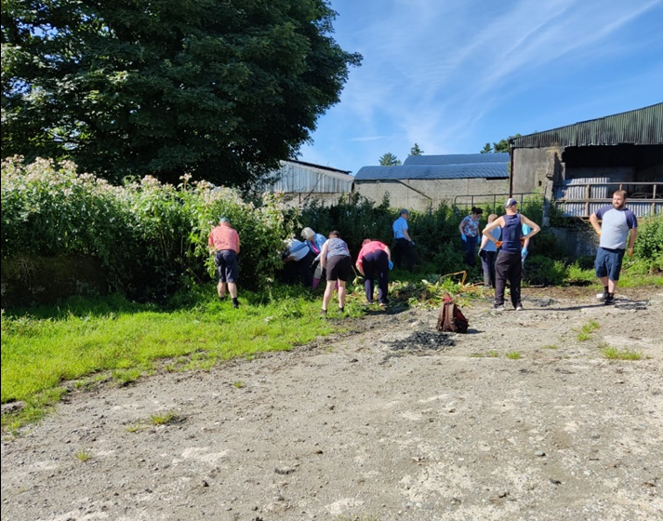
Background – It was noted that a large proportion of the twenty-six farms associated with the EIP held populations of High Invasive Impact Third Schedule Invasive Species (as per S.I.477/2011). Such species included; Himalayan Balsam (Impatiens glandulifera), Japanese Knotweed (Reynoutria japonica/ Fallopia japonica), Rhododendron (Rhododendron ponticum), and American Skunk Cabbage (Lysichiton americanus). As a result of this, meitheal working groups were developed, composing of host farmers and social farming participants, and funding provided in order to facilitate the safe removal of these species, where methods and locations were deemed appropriate.
Across 2022, six different meitheal events were undertaken by the EIP with a particular emphasis on invasive species management and methods. The above figure notes the attendance at a Himalayan Balsam treatment meitheal, where host farmers, social farming participants and members of the public attended in order to remove flowing plants for the farmyard of the Fleming farm, thus reducing the seedbank of the species within the surrounding soils in the subsequent years.
Goals – The aim of KESF EIP was to encourage host farmers and social farming participants to increase the area managed for nature on their farms, through habitat creation, management and improvement. The expansion of the overall project into the individual host farm issues, termed ‘the open action’, allowed invasive species identification, training and management to be included.
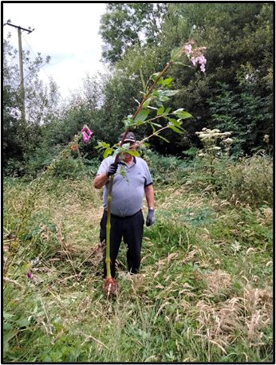
Approach – Through the scheduling of specific meitheal events and the payment of attendees, both host farmers and social farming participants, provision of equipment, lunches, tea, etc., invasive species management was achieved. The development of KESF EIP within a pre-existing project, Kerry Social Farming, allowed for health and safety aspects such as first aid kits, training courses and manual handling courses to have already been completed on host farms. The community-based nature of KESF EIP allowed for collaboration with multiple organisations and groups, particularly the McGillycuddy Reeks EIP and National Parks and Wildlife Service (NPWS). During this process, the McGillycuddy Reeks EIP provided guidance and invasive species training opportunities to host farmers and social farming participants and the NPWS provided information relating to their own farm plan scheme, along with methods relating to invasive species management within specific Annex I habitats.
Results – Two meitheals were undertaken in relation to the management of Himalayan Balsam (Impatiens glandulifera), one meitheal and two training courses were completed around the safe handling of herbicide and identification and management of Rhododendron (Rhododendron ponticum) and one working group meitheal was undertaken in order to manage American Skunk Cabbage (Lysichiton americanus). Himalayan Balsam (Impatiens glandulifera) was managed via hand pulling of plants, early in the flowering season, before seeding occurred. These meitheals required the purchase of gloves and biosecurity boot and PPE washing kits for each of the working days. Rhododendron (Rhododendron ponticum) was managed via direct stump treatment with herbicide. Over the meitheal which took place for the management of Rhododendron, young and flowering plants were targeted within an upland farm demonstrating the management techniques to other host farmers.
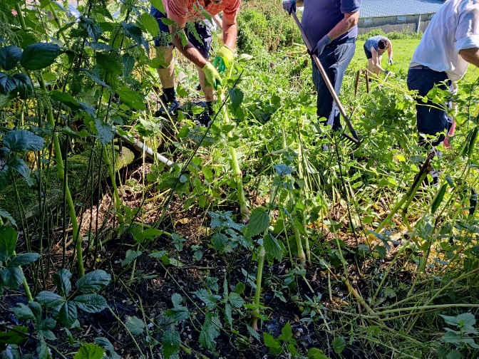
American Skunk Cabbage (Lysichiton americanus) was identified within a 12-acre wet woodland habitat, within the Castlemaine Harbour SAC (Site Code: 000343). This wet woodland is noted within the site’s conservation objectives map as being a qualifying interest, namely; 91E0 *Alluvial forests with Alnus glutinosa and Fraxinus excelsior. The woodland was noted as being of ‘high’ quality by local NPWS ranger, this is thought to be as a result of the low but persistent grazing which is completed on the site, reducing scrub density and allowing for ground floral indicator species. Year-round livestock units within the habitat are at an average of 2 LU year-round across the entire site, consisting a pony, donkey and three goats. Guidance from the NPWS was sought in relation to the management of this habitat for the removal of American Skunk Cabbage, it was noted that;
- The site lies within SAC 000343, which does not yet have a statutory instrument, as such works which require consent are listed as ‘Notifiable Actions’ for the specific QI habitats in which works are to be carried out. The method proposed for use (mechanical removal) did not correspond to any aspects of the list.
- It was also noted that the removal of the invasive plant would be ‘necessary to the management of the site’ and as such, an Appropriate Assessment was not required.
NPWS was notified of the removal of American Skunk Cabbage from the site and biosecurity measures were put in place in order to prevent the further spread of this invasive plant species. During 2022 a total 62 mature American Skunk Cabbage plants were removed from the site, infected soil and plant material (especially flowers and seed heads) was re-located to the farm yard for further treatment and assessment. The mechanical removal of these plants was completed by the host farmer, social farming participants and support staff. During the early spring meitheal in 2023, 6 American Skunk Cabbage plants were removed manually from the site.
Learnings – In total, 15-acres were managed for six across the meitheals and the entire project works, along with the educational benefits of hands-on learning and skills which came from physical management of these species.
Resources –
Higgins, G.T. (2008) Rhododendron ponticum: A guide to management on nature conservation sites. Irish Wildlife Manuals, No. 33. National Parks and Wildlife Service, Department of the Environment, Heritage and Local Government, Dublin, Ireland.
ISI, (2008) Best Practice Management Guidelines: Himalayan balsam (Impatiens glandulifera). Invasive Species Ireland. Dublin, Ireland.
KBR, (2022) Rhododendron Ponticum: Management for Farmers, Private landowners and Gardeners. Kerry Biosphere Reserve. Kerry, Ireland.
RAPID, (2018) Good Practice Management: American Skunk Cabbage (Lysichiton americanus). Reducing and Preventing Invasive Alien Species Dispersal.
This project was funded by the Department of Agriculture, Food and the Marine under the European Innovation Partnership Fund.

